**1. Purpose目的**

Unify the functional testing procedures and acceptable standard for T100i assy units in production line, to ensure the final quality can achieve the design spec and requirements.

统一和规范T100i组装后整机测试流程和允收标准，已确保整机质量符合设计规格和要求。

**2. Scope适用范围**

This document is suitable and mandatory for production functional testing for T100i assy units.

本测试流程适用于T100i组装产线的整机功能测试。

**3. Functional testing summary功能测试总结**

3.1 This testing procedure must be performed for each device, the sampling rate is 100%.

3.1 本测试流程须在产线100%执行

3.2 Failure classification: as all testing items in this document are functional testing and must be passed 100%, any failure in each testing item shall be treated as major problem to be rejected and recorded.

3.2 不良分类：本测试流程的所有测试项目均为功能测试并须100%执行，所有测试不良均为重大缺陷须拒收并记录

3.3 Testing record

For each failure, must stick label and mark the failure type/description, and the failure units must be [quarantined](http://dict.cn/quarantined).

For each testing items, the yield rate shall be recorded as per production lot.

测试记录：测试中的不良均须做好标签记录并且隔离；每个生产的批次，须记录并统计每项测试不良的比例。

3.4 List of testing items/flow测试项和流程（建议）

|  |  |  |  |  |
| --- | --- | --- | --- | --- |
| **No. of Testing Items**  **测试项次** | **Functions to be tested**  **功能测试点** | **Testing descriptions**  **测试描述** | **Testing equipments & tools**  **测试设备和工具** | **Acceptable criteria**  **允收标准** |
| 1 | Keys  按键测试 | Test Key functions are normal  手动测试按键功能正常：按键包括电源键和背部reset键  背部reset键分别确认短按和长按功能均正常 | / | Functions and feeling are fine  按键功能正常  按键手感正常 |
| 2 | Charging, Battery Green LED  充电片接触功能和电池指示绿灯测试 | Confirm charging and LED indication is correct  确认充电和充电指示绿灯正常 | Docking station | Charging green LED is blinking normal  插入座充后能正确充电，充电绿色灯闪烁正常，灯的亮度正常（人工判断，须培训） |
| 3 | SW version  软件版本 | Confirm SW versions are correct via AT command  确认GSM、TI和BLE软件正确 | ATE PC tool  PC, Docking | Match the requested version  匹配生产要求的版本, ATE自动判断 |
| 4 | Main chip ID  芯片ID | Confirm main chip ID is correct via AT command  确认主芯片ID | ATE PC tool  PC, Docking | 主芯片ID为6260D  ATE自动判断 |
| 5 | FSK ANT  FSK天线性能 | Check FSK receiver performance via AT command  检测FSK接收机性能 | ATE PC tool  PC, Dockings | The RSSI of dedicated docking signal should be higher than the defined value.  接收到指定FSK发送器的信号强度须大于确定的值，ATE自动判断 |
| 6 | BLE ANT  蓝牙天线性能 | Check BLE ANT performance via AT command  检测蓝牙天线性能 | ATE PC tool  PC, Docking, BLE host | The RSSI of dedicated BLE device should be higher than the defined value.  接收到指定蓝牙设备的信号强度须大于确定的值，ATE自动判断 |
| 7 | GPS ANT  GPS天线性能 | Check GPS receiver performance via AT command  检测GPS天线性能 | ATE PC tool  PC, Docking, GPS generator | The CN value received should be higher than the defined value.  接收到GPS的信号强度须大于确定的值，ATE自动判断 |
| 8 | GSM ANT  GSM天线性能 | Check GSM antenna performance by call testing via AT command  检测GSM天线性能，确认天线接触良好 | ATE PC tool  PC, Docking，  Agilent 8960 or CMU200 | The TX power is higher than defined value  发射功率大于指定值（自动或人工判断） |
| 9 | Buzzer  蜂鸣器功能 | Check buzzer function via AT command  检测蜂鸣器功能 | ATE PC tool  PC, Docking | Buzzer on/off correctly and Buzzer loudness is normal  蜂鸣器功能正常且响度正常（须培训），人工判断 |
| 10 | Torch  手电筒功能 | Check torch function via AT command  检测手电筒功能 | ATE PC tool  PC, Docking | Torch on/off correctly and Torch lightness is normal  手电筒功能且亮度正常（须培训），人工判断 |
| 11 | Signal Green LED  信号绿灯功能 | Check function of “signal green LED” via AT command  检测信号绿灯功能 | ATE PC tool  PC, Docking | Signal Green LED on/off correctly and lightness is normal  信号绿灯功能且亮度正常（须培训），人工判断 |
| 12 | Signal RED LED  信号红灯功能 | Check function of “signal red LED” via AT command  检测信号红灯功能 | ATE PC tool  PC, Docking | Signal Red LED on/off correctly and lightness is normal  信号红灯功能且亮度正常（须培训），人工判断 |
| 13 | IMEI check  检查IMEI | Check if IMEI is matching the one on the label via AT command  检测IMEI是否和背面标签上一致 | ATE PC tool  PC, Docking | IMEI is matching the one on the label  IMEI正确匹配（半自动判断，ATE判断前8位，人工判断后6位） |
| 14 | TI Shut Down, RED Battery LED  整机关机和电池指示红灯测试 | Check if whole device can be shut down correctly via AT  确认整机能正确关机且电池红灯显示正确 | ATE PC tool  PC, Docking | Red LED is lighted on during shut down process.  电池指示红灯在关机过程中常亮且亮度正常（须培训，人工判断） |
| 15 | Battery charging testing  电池充电测试 | Test battery can be fully charged in 2 hours  测试电池可在2小时内完成全部充电 | Travelling chargers | Fully charged after 2 hours with Green LED on, no hot when touch on housing  充电2小时候，电池绿灯常亮，外壳温度正常 |

**4. Testing procedures测试流程（建议）**

产线实际测试工位安排请工厂自行调整确定

**4.1 Preparation for testing tool生产测试工具准备**

**PC – 电脑**

Windows XP or Win7 system

Install with “MTK USB-2-COM” driver

Install with “T100i ATE PC tool”

**Docking Station**

The docking stations which are used for ATE testing as USB connector should be w/o FSK TX function

以上用于ATE测试的座充，仅局限于USB转换器的功能，为消除其它影响，须取消FSK发射功能

In order to disable FSK TX function, please remove component “L1” from docking PCBA, details please refer to following:

取消FSK发射功能，只需去掉docking PCBA上的元件L1，如下图所示：

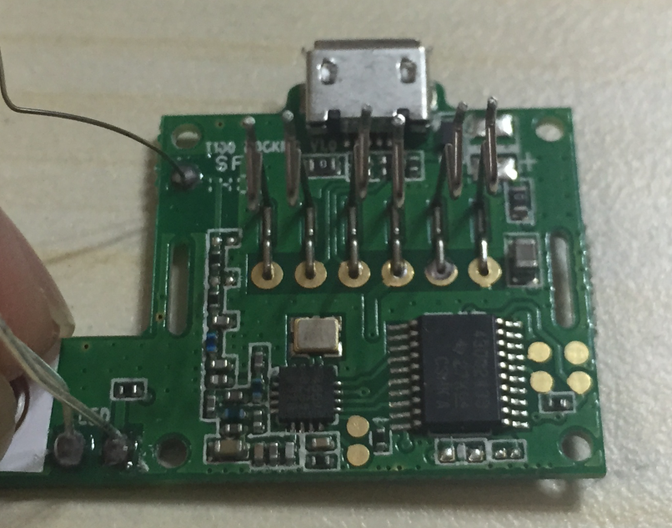

After remove L1 and plug in USB, the indicator LED will not light on.

去掉L1后，插入USB，白色LED指示灯将不会再亮起

**Other equipment/tools like Agilent 8960 or CMU200, GPS generator, BLE host, shield boxes need to be prepared also.**

**4.2 Testing process & description测试流程和说明**

建议按照3.4的流程逐项进行，工厂可依据实际情况进行调整，但调整后的作业须覆盖所列的测试点。

Test item 1/2: Key testing, charging contact/ charging indicator green LED testing

首先测试1/2项：按键测试，充电接触以及充电指示绿灯测试

首先短按电源按键，观察手电筒灯亮起然后红灯闪烁开机，待红灯闪烁3s后，然后短按背部的复位键，此时会重新开机，待红灯闪烁3s后，长按背部复位键，观察设备关机，红灯停止闪烁。

再将设备插入到座充中，观察设备自动开机，并且充电绿灯会闪烁。

Then test item 3~7, this is tested by ATE tool, the results are judged by ATE automatically. The standard which preset in the ATE is finalized by factory and Locca engineers.

接下来，用ATE测试工具测试表中3~7项，由生产工程师和Locca负责人共同确定好允收标准，测试结果由ATE自动判断。

Then do item 8 “call testing”, 接下来做呼叫测试，通过仪器确定发射功率正常。

Afterwards, test item 9~14, 测试项目9~14，用ATE工具测试，但测试结果需人工判断，因此作业人员需要经培训。

Final, test item 15 after device passes all above testing. 最后，测试项目15，待1~14项pass后，把设备放入到旅充充电，2小时后，确认充电完成。

**4.3 AT commands for ATE testing 测试AT指令集**

|  |  |  |
| --- | --- | --- |
| **Functions** | **AT command to T100i** | **Reply from T100i** |
| **Check SW versions** | AT^GT_CM=VERSION | VERSION=[gsm_version];[ti_version];[ble_version] |
| **Check Chipset ID Info** | AT^GT_CM=ID,1 | Chip RID:6260D |
| **Check BLE ID and RSSI** | AT^GT_CM=BT | AT^GT_CM=BleName(LoccaMinixxxx)+RSSI(-30) |
| **Check FSK ID and RSSI** | AT^GT_CM=FSK | AT^GT_CM=FSKID(1234)+RSSI(-30) |
| **Check motion sensor** | AT^GT_CM=MS | AT^GT_CM=MSDATA(x=1234,y=2345,z=5678) |
| **Make a call** | ATDxxx; | OK / No carrier |
| **End a call** | ATH | OK |
| **Read IMEI** | AT+EGMR=0,7 | 十IMEI: "358688000000158"IMEI?OK |
| **Write IMEI** | AT^GT_CM=IMEI,1,358899056396016 | FAIL!/OK! |
| **Turn on Signal Green Led** | AT^GT_CM=SIGNALGLED,1 | AT^GT_CM=SIGNALGLED,1 |
| **Turn off Signal Green Led** | AT^GT_CM=SIGNALGLED,0 | AT^GT_CM=SIGNALGLED,0 |
| **Turn on Signal Red Led** | AT^GT_CM=SIGNALRLED,1 | AT^GT_CM=SIGNALRLED,1 |
| **Turn off Signal Red Led** | AT^GT_CM=SIGNALRLED,0 | AT^GT_CM=SIGNALRLED,0 |
| **Turn on Batteryl Green Led** | AT^GT_CM=BATTERYGLED,1 | AT^GT_CM=BATTERYGLED,1 |
| **Turn off Batteryl Green Led** | AT^GT_CM=BATTERYGLED,0 | AT^GT_CM=BATTERYGLED,0 |
| **Turn on Torch Led** | AT^GT_CM=TORCHLED,1 | AT^GT_CM=TORCHLED,1 |
| **Turn off Torch Led** | AT^GT_CM=TORCHLED,0 | AT^GT_CM=TORCHLED,0 |
| **Turn on buzzer** | AT^GT_CM=BUZZER,1 | AT^GT_CM=BUZZER,1 |
| **Turn off buzzer** | AT^GT_CM=BUZZER,0 | AT^GT_CM=BUZZER,0 |
| **Turn on GPS** | AT^GT_CM=GPSTC,1 | $GPGVS……… |
| **Turn off GPS** | AT^GT_CM=GPSTC,0 | AT^GT_CM=GPSTC,0 |
| **Shut down device** | AT^GT_CM=SHUTDOWN | AT^GT_CM=SHUTDOWN |